Chapter 1

INTRODUCTION

1.1 BACKGROUND
In today’s fast-paced publishing industry, decision-making depends heavily on accurate, timely, and well-organized data reports. Traditional manual reporting methods are slow, error-prone, and resource-intensive, which creates inefficiencies in tracking sales performance and analyzing business trends.
To address these challenges, the Reporting Web Application is developed as a secure, browser-based platform designed for a leading publication house. The system enables users to generate, manage, and analyze reports efficiently through an intuitive interface. By providing interactive charts, tables, and filtering options, it helps users gain actionable insights from complex datasets.
- Data centralization for easy access and management.
- Dynamic report generation that can adapt to business needs.
- Visual representation of sales growth and performance.

1.2 PROBLEM DEFINITION /STATEMENT
In the publishing industry, timely and accurate reporting is crucial for analyzing sales, monitoring growth, and supporting informed decision-making. However, the existing manual methods of report generation are time-consuming, prone to human error, and lack real-time insights. These processes often require significant effort to collect, process, and present data, leading to delays and inefficiencies in business operations.

1.3 OBJECTIVES
- To develop a web-based reporting application that efficiently generates detailed and dynamic reports from stored data.
- To centralize the reporting process to minimize manual effort and reduce human errors.
- To optimize backend performance for fast data retrieval and smooth report generation.

1.4 SCOPE OF THE PROJECT
The Reporting Web Application aims to streamline the process of report generation, management, and analysis for businesses, especially in the publishing industry. It provides a centralized and secure platform that enables users to access, view, and analyze data in an organized manner. The application is designed to enhance the efficiency of business reporting by replacing traditional manual methods with an automated, user-friendly web-based system.
The scope of this project includes the development of various modules that allow users to generate dynamic reports, apply filters, and visualize data through interactive charts and graphs. It ensures secure data access using authentication and role-based permissions, preventing unauthorized usage. The system will also include features for tracking sales growth and analyzing business performance over time, offering insights that assist in informed decision-making.

1.5 APPLICATION
- Business Data Analysis:
It helps management teams generate detailed reports that reveal performance trends, sales growth, and operational efficiency.
- Sales Tracking:
The application allows businesses to monitor sales performance and growth over time. By visualizing data through charts and graphs.
- Secure Data Management:
The web app ensures secure access and storage of sensitive business data through authentication and authorization mechanisms.
- Performance Monitoring:
Managers and team leaders can use the system to track employee or departmental performance through periodic reports.

Chapter 2
LITERATURE REVIEW

2.1 EXISTING SYSTEM /RELATED WORK

In this system, most organizations rely on manual or semi-automated methods for report generation and data analysis. These reports are often created using tools like Microsoft Excel or Google Sheets, where users manually collect, enter, and analyze data. Such processes are time-consuming, prone to human error, and often lack real-time data synchronization. As a result, decision-makers face delays in accessing accurate information, which affects business performance and responsiveness.
Some organizations use basic web-based dashboards or standalone reporting tools, but these systems often lack essential features like role-based access control, dynamic filtering, and interactive visualization. Moreover, many existing applications do not provide secure centralized access, making data management complex and less efficient. In addition, integration with live databases or automated data fetching is often limited, which restricts real-time analysis.
To overcome these limitations, the proposed Reporting Web Application aims to provide a secure, interactive, and automated solution that simplifies the reporting process

2.2 LIMITATIONS OF EXISTING SYSTEMS
- No Centralized Platform:
Data is often scattered across multiple files or systems, making it difficult to access and manage efficiently.
- Lack of Real-Time Data:
Reports are not updated automatically, leading to outdated or inaccurate information during analysis.
- Low Efficiency and Scalability:
As the data volume grows, manual systems become slow and inefficient, making them unsuitable for large-scale organizations.
- Difficult Data Sharing:
Reports or datasets cannot be easily shared among team members without manual transfer, which leads to communication delays.

- Complex Maintenance:
Maintaining and updating multiple files or report formats requires significant manual effort and technical knowledge.

2.3 RESEARCH GAP
- Secure API Development in C# Using JWT Authentication:
This study explains how to secure APIs using JSON Web Tokens (JWT) for authentication and authorization. But it does not explore advanced security measures such as anomaly detection, API rate limiting, or AI-driven threat prevention.
- Testing and Debugging C# APIs with Postman and xUnit:
This paper emphasizes techniques for testing and debugging APIs effectively using Postman and xUnit frameworks. However, it lacks focus on continuous integration and delivery (CI/CD) automation, which is essential for large enterprise applications
- Designing RESTful APIs with ASP.NET Web API:
This paper focuses on building RESTful APIs using ASP.NET Web API for efficient data exchange. However, it offers limited discussion on performance optimization techniques like caching, asynchronous streaming, and connection pooling for large-scale applications
- Web-Based Data Visualization for Business Intelligence Systems:
This paper discusses the use of web technologies for creating data visualization dashboards in business intelligence systems. However, it does not address the challenges of real-time data synchronization, scalability, and secure multi-user access, which are crucial for modern reporting applications.

Chapter 3
SYSTEM ANALYSIS

3.1 REQUIREMENT ANALYSIS
The Reporting Web Application requires a well-balanced combination of hardware, software, and functional components to ensure efficient data processing, secure access, scalability, and real-time reporting for users and administrators..

Hardware Requirements:
- Processor: Intel Core i3/i5 Or Equivalent (4 Cores Minimum)
- Ram: 8 Gb (16 Gb Recommended)
- Storage: Browser Based Application (Storage not required)
- GPU : Optional, For Multimedia And Analytics Processing

Software Requirements:
- Frontend: ReactJS, HTML ,CSS, JavaScript
- Backend: C# and JQuery
- Database: MySql

Functional Requirements:
- To generate detailed and dynamic reports based on stored business data.
- To visualize sales and performance data through interactive charts and graphs.
- To manage user accounts and maintain secure access logs.
- To provide user authentication and role-based access control for admin and authorized users.

Non-Functional Requirements:
- The interface should be simple, intuitive, and user-friendly.
- The system should easily handle an increasing number of users and data records.
- The system should respond quickly even with large data volumes.
- The application should function smoothly on all major browsers.

3.2 FEASIBILITY STUDY
A feasibility study is conducted to determine the practicality, efficiency, and success potential of developing the Reporting Web Application. It evaluates the technical, operational, economic, and legal aspects of the system to ensure that the project can be implemented effectively within the given constraints.
- TECHNICAL FEASIBILITY:
The proposed Reporting Web App is technically feasible as it utilizes modern and stable technologies. The frontend is developed using React.js, HTML, CSS, and JavaScript, which ensures a responsive, dynamic, and user-friendly interface. The backend uses C# for server-side logic and jQuery for enhanced interactivity, providing smooth communication between the client and the server.
- ECONOMIC FEASIBILITY:
The economic feasibility of the project is high because it relies primarily on open-source and cost-effective technologies such as React.js and MySQL. The development cost is limited to domain registration, hosting services, and minimal maintenance charges, which are estimated to be around ₹10,000–₹15,000.
Over time, the system will reduce operational costs by automating report generation, minimizing manpower needs, and improving overall productivity.
- OPERATIONAL FEASIBILITY:

The system is operationally feasible because it replaces manual and error-prone reporting processes with an automated, centralized web platform. Users such as administrators and managers can easily generate, view, and analyze reports without extensive technical knowledge.

3.3 PROBLEM IDENTIFICATION AND PROPOSED SOLUTION
In many organizations, report generation and data analysis are still performed manually using spreadsheets or basic tools. This traditional approach leads to several challenges such as time-consuming processes, frequent human errors, poor data visualization, and lack of real-time information. Moreover, without a centralized and secure platform, managing, sharing, and updating reports becomes inefficient, which affects overall productivity and decision-making accuracy..
To overcome these challenges, the proposed Reporting Web Application provides a centralized, automated, and secure system for generating and managing business reports. Developed using React.js, HTML, CSS, and JavaScript for the frontend and C# with MySQL for the backend, the application enables users to generate dynamic reports, visualize data through interactive charts, and access real-time insights. With role-based authentication and a user-friendly interface, the system ensures data security, reduces manual effort, and enhances decision-making efficiency within the organization.

1. PROPOSED SOLUTION
The aims to overcome the limitations of traditional manual reporting systems by introducing an automated, secure, and centralized web-based platform. It is designed to streamline report generation, enhance data visualization, and improve decision-making efficiency for organizations..
- It uses React.js, HTML, CSS, and JavaScript for building a dynamic and user-friendly interface, ensuring smooth interaction and responsive design.
- The backend is developed in C# with jQuery, which handles server-side operations, logic execution, and communication with the database effectively.
- MySQL is used as the database to securely store and manage all report-related information, ensuring data consistency and integrity.
- The system provides a centralized reporting dashboard where all business data can be accessed, analyzed, and managed efficiently..
- The system integrates interactive charts and graphs, allowing visualize complex data trends easily and make better business decisions..

Chapter 4
SYSTEM DESIGN

4.1 SYSTEM ARCHITECTURE

AVG Transact Value
Total Sales Value
Product Quantity
Sales Register
Target VS Actual
Monthly Sales
Reports
Graphs
KPIs
account executive
Sales Operations Manager
Owner

Registration Page

Admin

Sales Booking

Profit Margin

Monthly Sales

Dashboard

Owner

account manager

Login Page

sales development representative

Role

1. Level 0 DFD
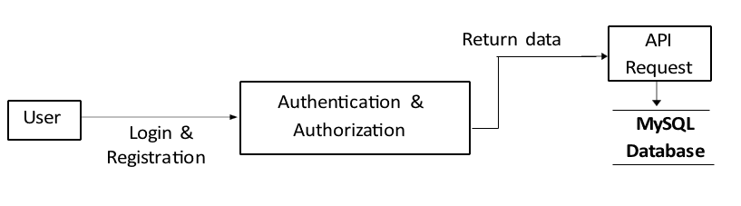

2. Level 1 DFD

Download Reports

Owner or Admin

Register New User

Database

Recover Password

Authorize User

Specific Month Data

API

4.3 UML Diagrams
1. ACTIVITY DIAGRAM
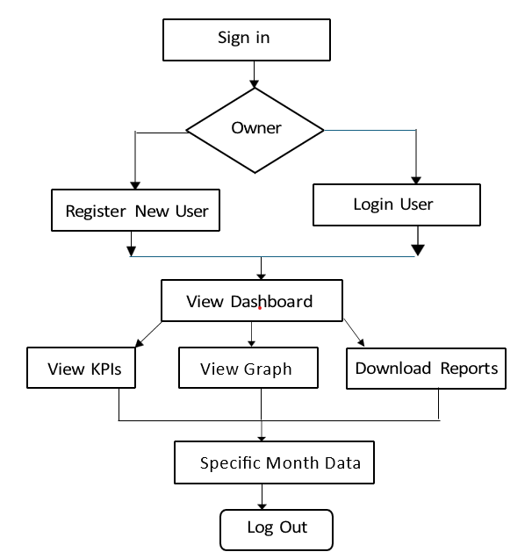

4.3 Database Design

user_role
ID | Numeric
Name | String
CreatedBy | Numeric
CreatedOn | DateTime
ModifiedBy | Numeric
ModifiedOn | DateTime
IsActive | Boolean

user_master
ID | Numeric
Name | String
Email | String
Phone | Numeric
Password | String
UserRoleID | Numeric
CreatedBy | Numeric
CreatedOn | DateTime
ModifiedBy | Numeric
ModifiedOn | DateTime
IsActive | Boolean

state_master
ID | Numeric
Name | String
CreatedBy | Numeric
CreatedOn | DateTime
ModifiedBy | Numeric
ModifiedOn | DateTime
IsActive | Boolean

product_master
ID | Numeric
Code | String
Name | String
UnitPrice | Numeric
CreatedBy | Numeric
CreatedOn | DateTime
ModifiedBy | Numeric
ModifiedOn | DateTime
IsActive | Boolean

customer_master
ID | Numeric
Name | String
CreatedBy | Numeric
CreatedOn | DateTime
ModifiedBy | Numeric
ModifiedOn | DateTime
IsActive | Boolean

sales_target
ID | Numeric
StateID | Numeric
MonthName | String
Year | Numeric
TargetAmount | Numeric
CreatedBy | Numeric
CreatedOn | DateTime
ModifiedBy | Numeric
ModifiedOn | DateTime
IsActive | Boolean

sales_transaction_details
ID | Numeric
ProductId | Numeric
SalesID | Numeric
UnitPrice | Numeric
Quantity | Numeric
Amount | Numeric
CreatedBy | Numeric
CreatedOn | DateTime
ModifiedBy | Numeric
ModifiedOn | DateTime
IsActive | Boolean

Sales_transaction
ID | Numeric
SalesDate | Date
CustomerID | Numeric
StateID | Numeric
CreatedBy | Numeric
CreatedOn | DateTime
ModifiedBy | Numeric
ModifiedOn | DateTime
IsActive | Boolean

production_cost
ID | Numeric
ProductId | Numeric
Cost | Numeric
Month | Numeric
Year | Numeric
CreatedBy | Numeric
CreatedOn | DateTime
ModifiedBy | Numeric
ModifiedOn | DateTime
IsActive | Boolean

Chapter 5

IMPLEMENTATION DESIGN

5.1 SOFTWARE & HARDWARE REQUIREMENTS

Software components | Description
Operating system | Windows 11, MAC OS
Frontend framework | React.js with bootstrap for building responsive and interactive user interface
Back-end technologies | C# and JQuery for handling server-side logic and API integration
Database | MySQL for storing users, learning paths, modules, and progress data
Development environment | Visual Studio 2022

5.2 TOOLS & TECHNOLOGY
1.Front-End Technologies

Tool/Language | Purpose/Role in Project
HTML5 (Hypertext  Markup Language) | Used to design the structure of all web pages including login, dashboard, and KPI cards. Defines layout and content placement.
JavaScript (ES6+) | Adds interactivity, handles dynamic data rendering, and ensures a smooth and responsive user experience.
React.js with Bootstrap | Builds modular, fast-loading user interfaces with reusable components and responsive layouts.

- Back-End Technologies

Back-End Technology | Description
ASP.net | ASP.NET Core Web API is a high-performance, cross-platform framework used to build secure and scalable RESTful services. It offers built-in dependency injection and flexible middleware, making backend development clean and efficient.
WEB API | A Web API allows different software applications to communicate with each other over the internet using standard protocols. It enables data exchange between client and server, supporting integration across web, mobile, and external systems.
Swagger | Swagger is a tool that automatically generates interactive API documentation for Web APIs. It allows developers to test API endpoints directly in the browser, making development and debugging easier.

- Database & Development Environment

Development & Integration Tool | Description
MySQL Workbench | MySQL Workbench is a visual tool for designing, managing, and querying MySQL databases. It provides an easy-to-use interface for creating tables, running SQL queries, and managing database connections.
Visual Studio 2022 | Visual Studio 2022 is an integrated development environment used to build, debug, and deploy applications. It provides powerful tools, IntelliSense, and a user-friendly interface to support coding across multiple languages and platforms.

5.3 SCREENSHOTS AND WORKING MODULES
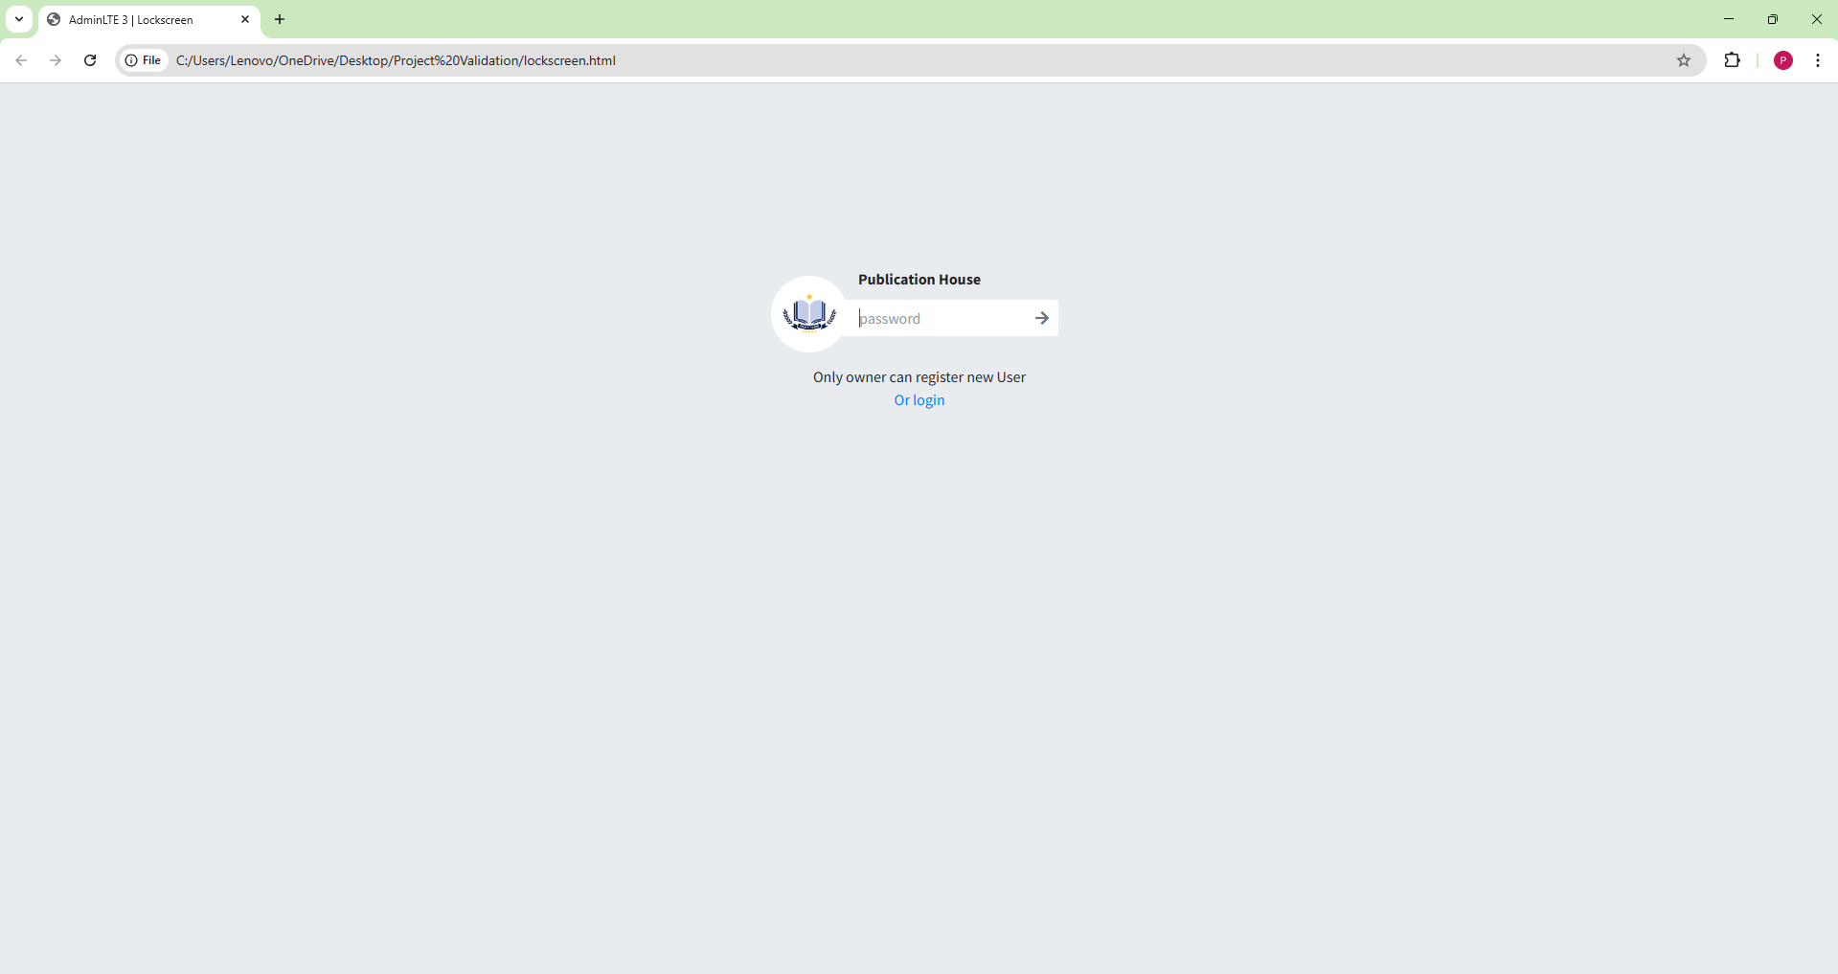
Fig. Admin / Owner Login Page

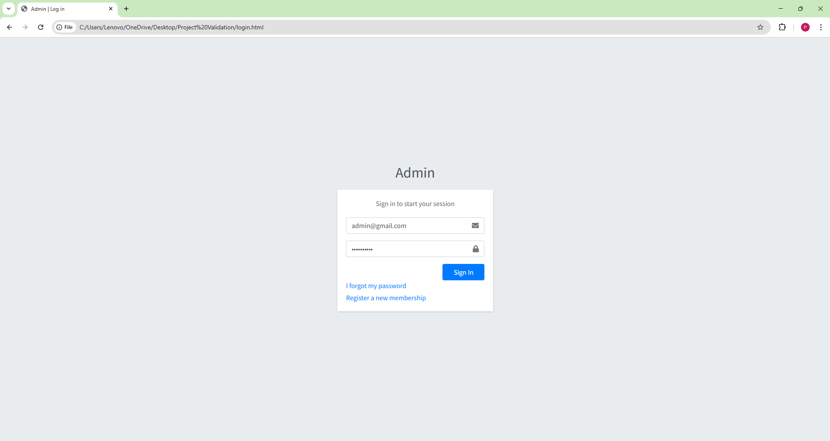
Fig. User Login
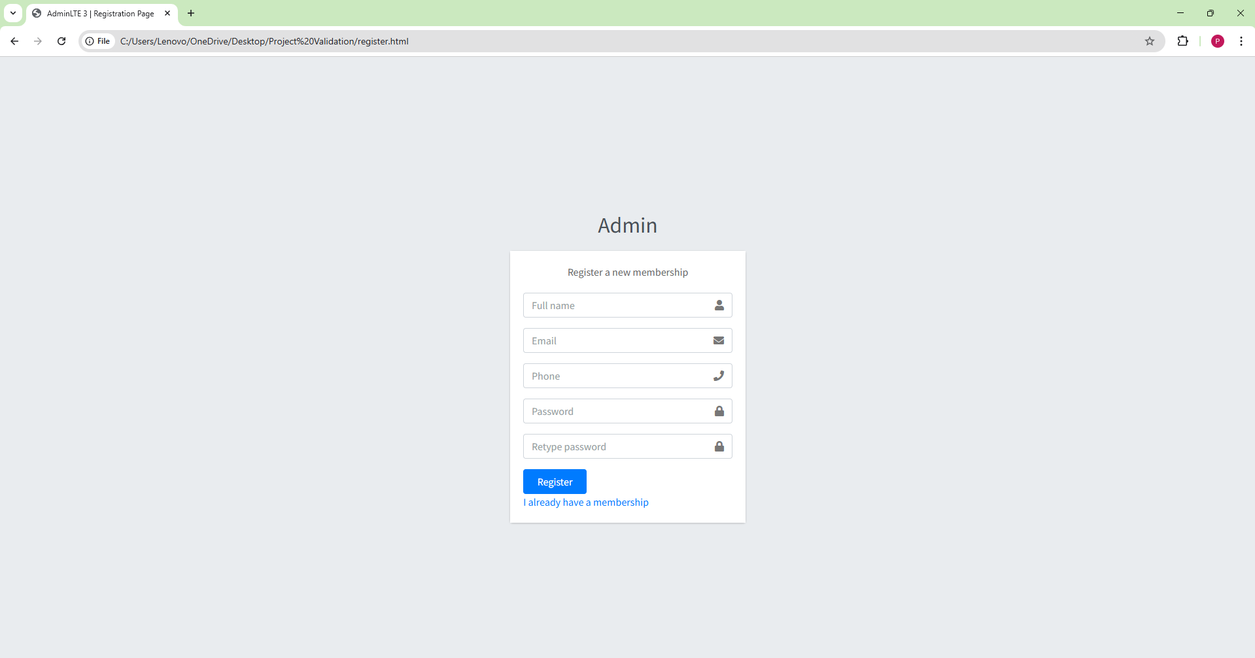
Fig. User Sign Up

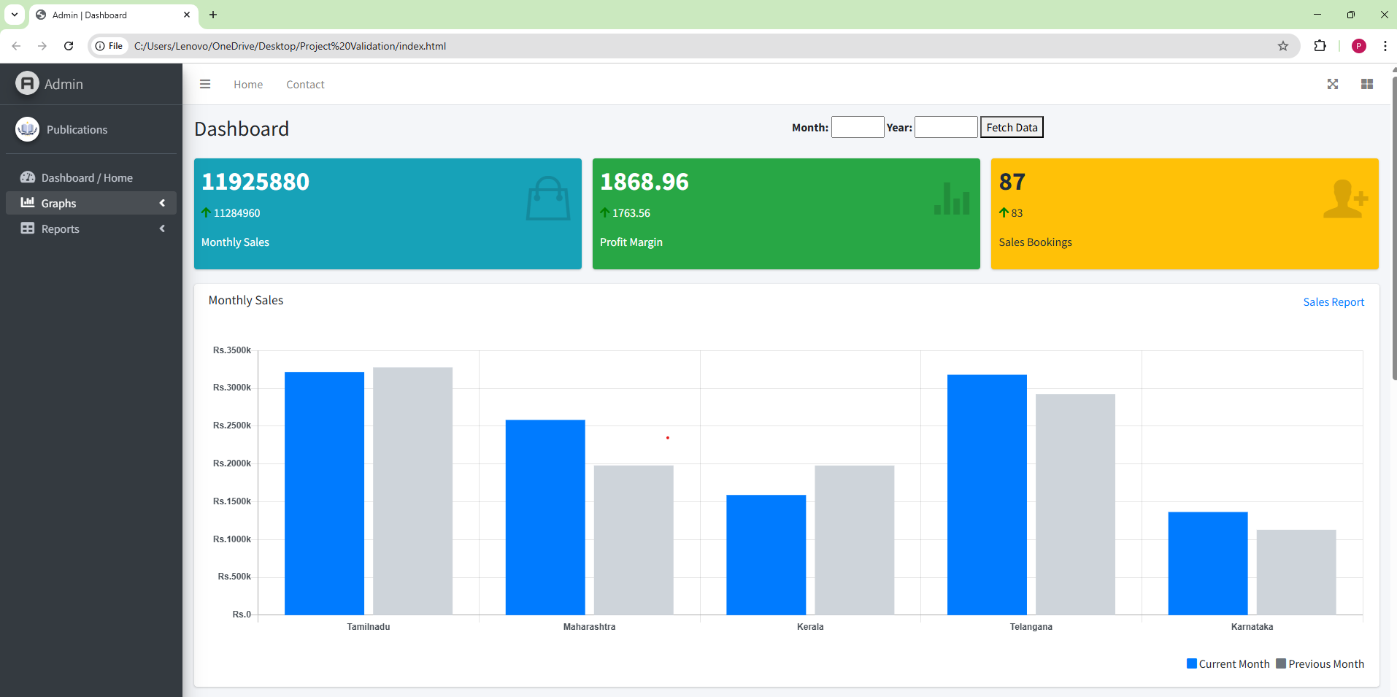
Fig. Main Dashboard

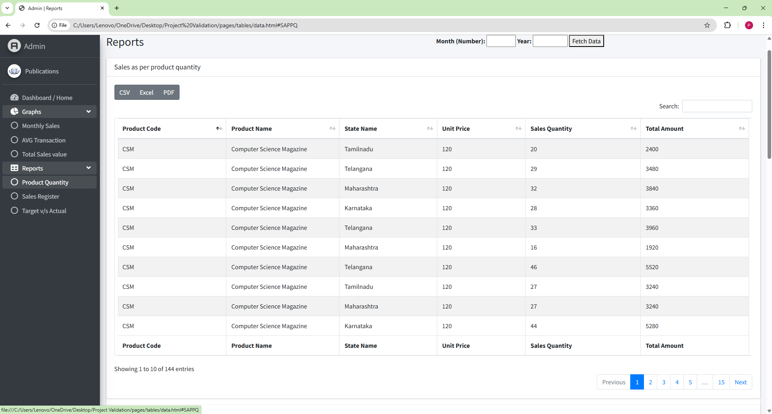
Fig. Reports

Chapter 6

REFERENCES

REFERENCES
- React Documentation, “A JavaScript library for building user interfaces,”
Available at: https://react.dev

- MDN Web Docs, “HTML, CSS, and JavaScript Web Standards and Guides,”
Available at: https://developer.mozilla.org

- jQuery Documentation, “A Fast and Feature-rich JavaScript Library,”
Available at: https://api.jquery.com

- ASP.NET Core Documentation, “Modern Web Development Framework for .NET,” Microsoft,
Available at: https://learn.microsoft.com/aspnet/core

- C# Programming Guide, “Language and Runtime Features,” Microsoft,
Available at: https://learn.microsoft.com/dotnet/csharp

- MySQL Documentation, “Relational Database Management System,”
Available at: https://dev.mysql.com/doc

- MySQL Workbench User Guide, “Database Design and Administration Tool,”
Available at: https://dev.mysql.com/doc/workbench/en

- Bootstrap Documentation (optional if used), “CSS Framework for Responsive UI Design,”
Available at: https://getbootstrap.com

- Visual Studio 2022 Documentation, “Integrated Development Environment for .NET Applications,” Microsoft,
Available at: https://learn.microsoft.com/visualstudio

- W3Schools, “Web Development Tutorials and Examples,”
Available at: https://www.w3schools.com

- Coursera, “Online Learning Platform for Programming and Web Development Courses,”
Available at: https://www.coursera.org

- Udemy, “Online Courses Platform for Technology and Software Development,”
Available at: https://www.udemy.com

